Ref. No.: IVM/KBIPER/Ex-Cu/2025-26/ Date:20/04/2026

REPORT

01 | Date of activity | 17/04/2026
02 | Total Attendance | No. of Participated Students: 450  No. of Staff: 40
03 | Occasion of Activity | ASHWAMEDH Cultural Program
04. | Objective | The event aimed to provide a platform for students to showcase their cultural talents such as dance, music, and various performance arts. It focused on promoting teamwork, leadership, and coordination skills among students while encouraging overall personality development beyond academics. Additionally, the program helped strengthen student engagement and institutional bonding, and contributed to preserving and promoting cultural values and creativity among students.
 | Summary Report | The Annual Cultural Festival ASHWAMEDH 2026 was celebrated with great enthusiasm at Krishnarao Bhegade Institute of Pharmaceutical Education and Research, Talegaon Dabhade, under Indrayani Vidya Mandir. The event was graced by Dr. Harshadeep Joshi as Chief Guest and presided over by IVM’S Secretary Honb. Shri. Chandrakant Shete. Dignitaries including Dr. Sambhaji Malghe, Dr. Sahebrao Patil, and Gorakh Kakade were present.  The program began with a welcome address and annual report by Principal Dr. S. R. Arote, followed by a student address from General Secretary Pratik Bhaik. The Chief Guest delivered an inspiring speech on career opportunities and social responsibilities in the pharmaceutical field.  Cultural performances coordinated by Ms. Ashvini Joshi and Ms. Shweta Mantri included dance and music, showcasing student talent. The event concluded with a vote of thanks by HOD Dr. G. S. Shinde and was successfully conducted with the support of IVM’S President Honb. Shri Ramdas Kakade, IVM’S Treasurer Honb. Mrs. Nirupa Kanitkar, IVM’S Trustee Honb. Shri. Sanjay Sane, Honb. Shri. Shailesh Shah.
06 | Activity co-coordinator | Ms. A.V.Joshi  Ms. Shweta Mantri

Geotag photos of “ASHWAMEDH Cultural Program 2026’’

SARASWATI PUJAN BY CHIEF GUEST  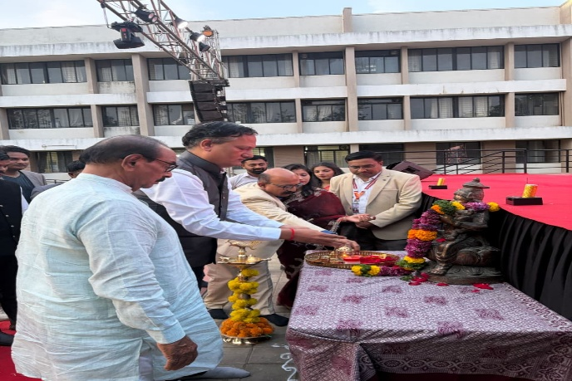  STUDENT’S PERFORMANCES  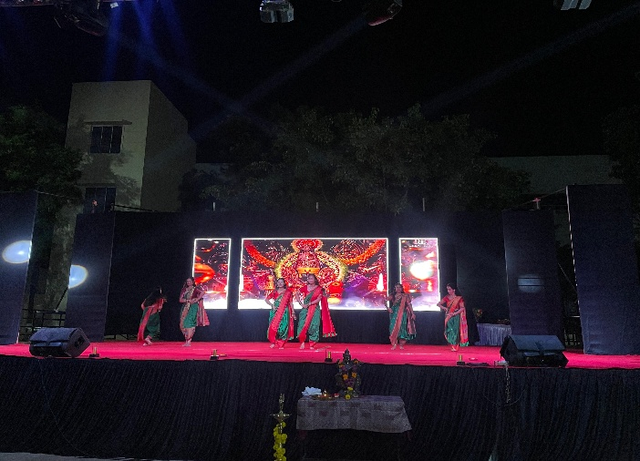 | DIGNITARIES FOR THE EVENT  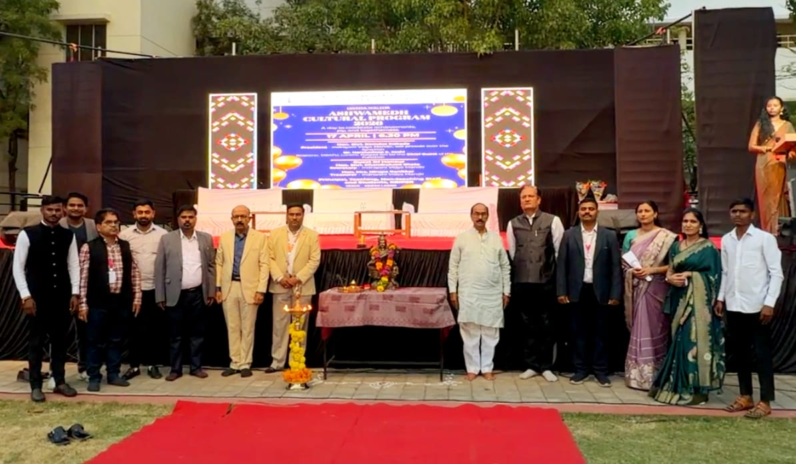  GROUP PHOTO OF STUDENTS  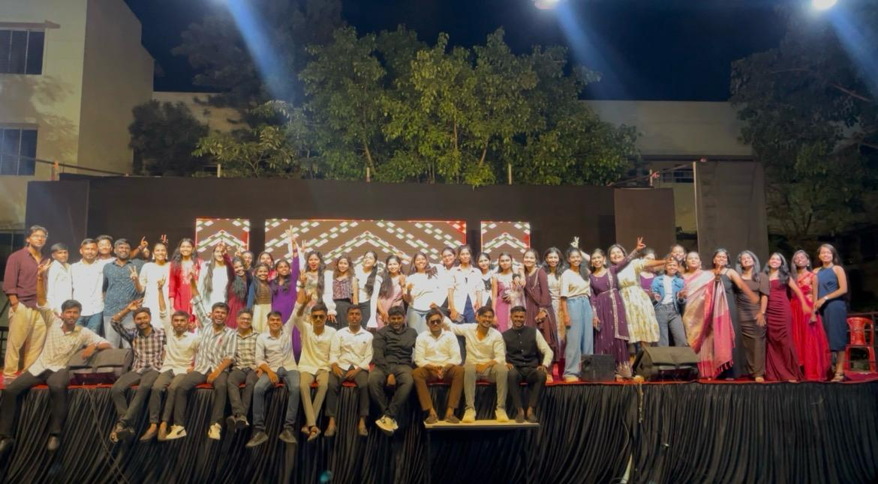

Extracurricular Coordinator IQAC Head HOD Principal
Ms. A.V.Joshi Dr.Y.B.Zambare Dr.G.S.Shinde Dr. Sanjay R. Arote
Ms. Shweta Mantri

